Introduction to Acoustics
Complete the following problems and fill your answers in below. Only submit the portion of the assignment from here on (you can erase what is above for submission). You will need a word processing and spreadsheet software package to complete it. Upload to Blackboard in the weekly activity section. Don’t forget to include your name!!

1. Compute the periods for each of the frequencies listed on the x-axis of the graph below, record them and plot them, connecting the plotted points with a continuous curve. Round to the nearest whole number (your values should match the ones on the y-axis). I have provided the scale values for the x-axis but you will provide the label for the y-axis (what is the unit of measure for the y-axis?). Here is an example of how to do a similar problem: https://youtu.be/ClOLcwWx9aQ. If you want to create your own graph in excel, be sure to show labels for the axes so I know you know the values (and then copy and paste that graph in this document, replacing the graph below). Otherwise, you can print this one page and graph it by hand (and fill in the unit of measurement for the y-axis) and take a picture of it. Use that picture to replace the graph below.

T-values when f is:

150Hz_6667µs_ 400Hz_2500µs__1050Hz_952µs__ 1350Hz_741µs___ 2500Hz_400µs__ 3000Hz__333µs__

The choice of microseconds as the unit of measure is based on the fact that microseconds become inaccurate as the frequency increases.

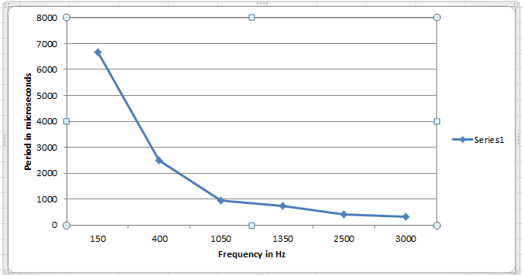

2. Based on your line graph, what can you say about the relationship between frequency (f) and period (T)?

Frequency (f) and period (T) share an inverse relationship. If the frequency increases, the period decreases and vice versa.

3. Compute the wavelength for each of the frequencies listed below. Then, record them and plot them in Excel (or whatever you use as a spreadsheet software), connecting the plotted points with a continuous curve. Round to the nearest whole number. Be careful with your measurement values (be consistent!). Label both axes (with words). If you are not sure how, an internet search will help you figure out how to label graph axes in your software package. Look at the empty graph above for some help.

Wavelength when f is:

150Hz_224 cm_ 400Hz_84 cm_ 1050Hz_32 cm_ 1350Hz_25 cm_ 2500Hz_13cm_ 3000Hz_11cm_

Paste your graph below.

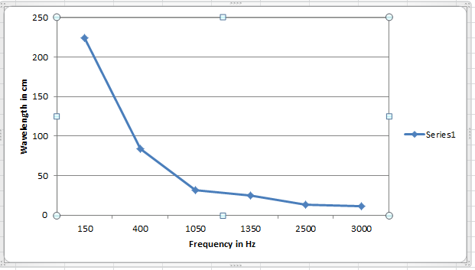

4. We have the sinusoidal function $D=A\sin{(2πft+ ∅}$) that will tell us the displacement of an object at any given moment in time. But, if we are not interested in the absolute starting phase of the waveform, we can simply to $D=A \left(sin∅\right)$, where $∅$ is the angle formed between reference radii. What was left out in the new formula and why do you think we can simplify this way?

We are only left with the displacement of an object without reference to time.

5. Using the simplified sinusoidal motion formula, $D=A \left(sin∅\right)$, and the table of sines below, plot the amplitudes as a function of time (time of observation below) for the following data, where A = 20. Use spreadsheet software to create your plot and label the plot completely. Here is a short tutorial: https://youtu.be/g31f52E2tR0. Fill in the Amplitude column below and copy and paste your plot below the table.

Plot these data |  |  | Sine Table
Time | Angle | Amplitude | 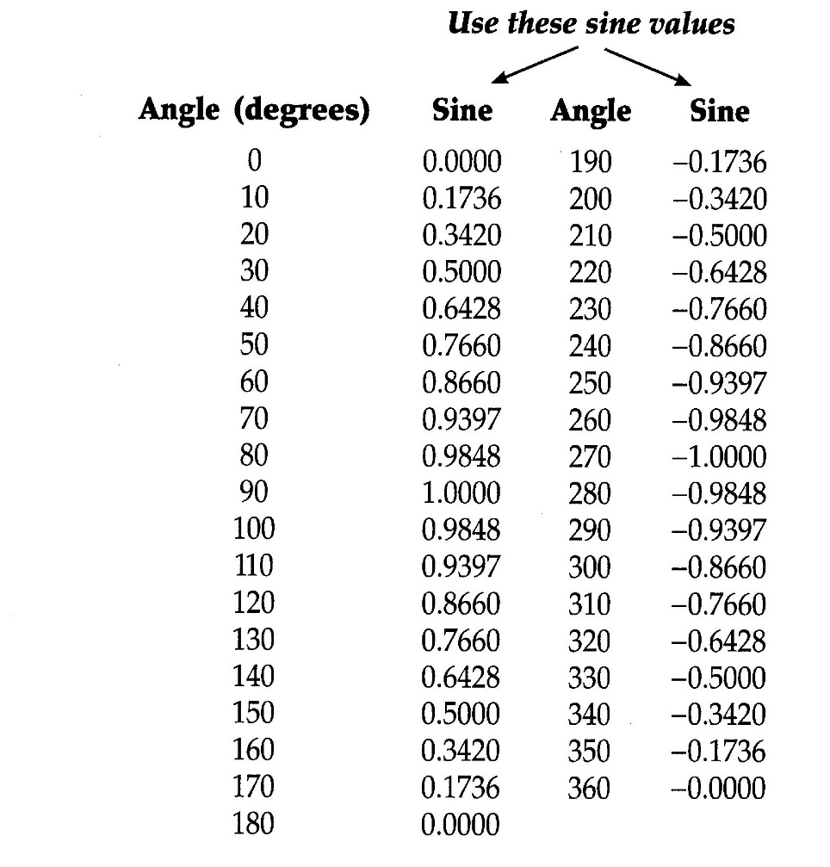
0 | 0 | 0
1 | 30 | 10
2 | 80 | 19.696
3 | 110 | 18.794
4 | 160 | 6.84
5 | 180 | 0
6 | 220 | -12.856
7 | 260 | -19.696
8 | 300 | -1.732
9 | 340 | -6.84
10 | 0 | 0

